Ross Thyne

Thomas Collins

Charlie Nitschelm

Lucas Simmonds

Joseph Williams

ME 643

Deliverable 1

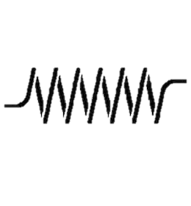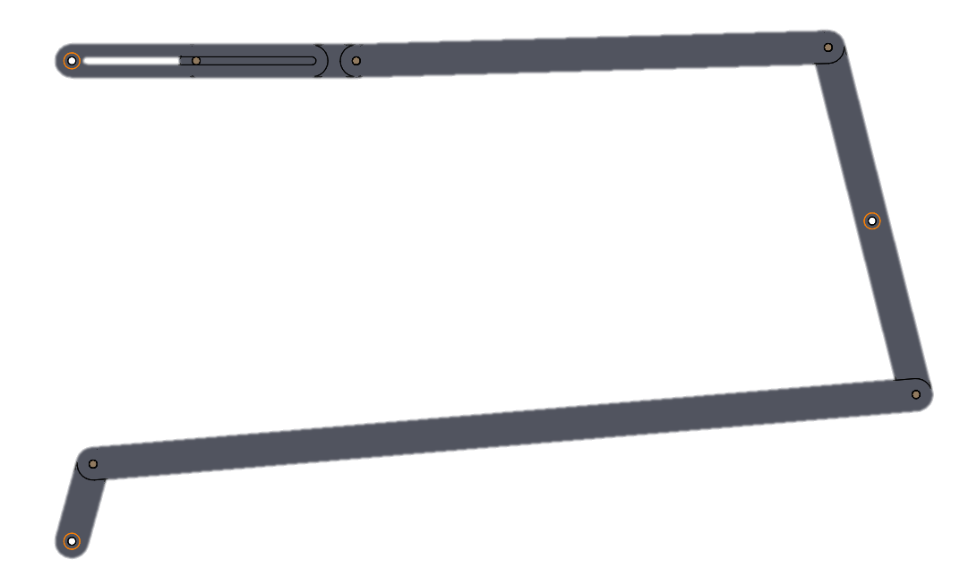

F

E

B

D

C

A

o

Figure #1: Problem Statement Diagram

Our Calculations

Loop #1: L1 + L2 + L31 - OC = 0

Loop #2: OC + L32 + L4 – S – OF = 0

Next we parametrized or loop equations into X & Y components.

Loop #1 Parameterization

ROA + RAB + RBC – RCO = 0

ROA = rOA {cosθ, sinθ}

RAB = rAB {cosθA, sinθA}

RBC = rBC {cosθB, sinθB}

RCO = {XC,YC}

Loop #2 Parameterization

ROC + RCD + RDE - REF - RFO = 0

RCD = rCD {cosθB, sinθB}

RDE = rDE { cos(θD) , sin( θD) }

REF = rEF {1, 0}

RFO = rFO {0, 1}

Projecting Loop #1&2 parameterizations on X and Y axis to get position equations.

Loop #1

rOAcos(θ) + rABcos(θA) + rBCcos(θB) – XC = 0 (X)

rOAsin(θ) + rABsin(θA) + rBCsin(θB) – YC = 0 (Y)

Loop #2

XC + rCDcos(θB) + RDEcos(θD) – rEF = 0 (X)

YC + rCDsin(θB) + RDEsin(θD) – rFO = 0 (Y)

Where θA, θB,θD, and rEF are our unknowns to be solved for. Taking the derivative of the position equations above with respect to time we get our velocity equations.

Loop #1

-rOAsin(θ) - rABAsin(θA) - rBCBsin(θB) = 0 (X)

rOAcos(θ) + rABAcos(θA) + rBCBcos(θB) = 0 (Y)

Loop #2

-rCDBsin(θB) - rDEDsin(θ D) -EF = 0 (X)

rCDBcos(θB) + rDEDcos (D) = 0 (Y)

Where A,B,D, andEF are our unknowns to be solved for. Taking derivative of the velocity equations above with respect to time we get our acceleration equations.

Loop #1

-rOAsin(θ)-rOA2cos(θ) - rABAsin(θA) - rAB2Acos(θA) - rBCBsin(θB) - rBC2Bcos(θB) = 0 (X)

rOAcos(θ) -rOA2sin(θ) + rABAcos(θA) - rAB2Asin(θA) + rBCBcos(θB) - rBC2Bsin(θB) = 0 (Y)

Loop #2

-rCDBsin(θB) - rCD2Bcos(θB) - rDEDsin(θ D) - rDE2Dcos(θ D) -EF = 0 (X)

rCDBcos(θB) - rCD2Bsin(θB) + rDEDcos(θ D) - rDE2Dsin(θ D) = 0 (Y)

Where A,B,D, and EF are our unknowns to be solved for.

The forces on each pin were then computed mathematically.

Forces on Pins

Member 1

$$F_{ox}+F_{ax}=0$$

$$F_{oy}+F_{ay}=0$$

$$M_{o}+ F_{ay}∙R_{oa, y }- F_{ax}∙R_{oa, x}- F_{ox}∙R_{oa, y }+ F_{oy}∙R_{oa, x }=0$$

Member 2

$${-F}_{ax}+F_{bx}cosθ_{B}=0$$

$${-F}_{ay}+F_{bx}sinθ_{B}=0$$

$$- F_{ax}∙R_{ab, x }- F_{ay}∙R_{ab, y}- F_{bx}∙R_{ab, x }+ F_{by}∙R_{ab, y}=0$$

Member 3

$$F_{cx}-F_{bx}+F_{pin,x}=0$$

$$F_{cy}+F_{by}+F_{pin,y}=0$$

$$F_{bx}∙R_{bc, x }- F_{by}∙R_{bc, y}- F_{cx}∙R_{bc, x }+ F_{cy}∙R_{bc, y}=0$$

Member 4

$$-F_{cx}+F_{dx}=0$$

$$-F_{cy}+F_{dy}=0$$

$$- F_{cy}∙R_{cd, x }- F_{cx}∙R_{cd, y}- F_{dy}∙R_{cd, x }+ F_{dx}∙R_{cd, y}=0$$

Member 5

$$2- X_{e}-F_{dx}-0.05∙a_{E}=0$$

$$F_{N}+F_{dy}-F_{g}=0$$

To calculate the Axial and Transverse force we needed to project the forces onto X and Y axis

Loop 1

$$R_{oa,x}=(\frac{R_{oa}}{2})∙cos⁡θ$$

$$R_{oa,y}=(\frac{R_{oa}}{2})∙sin⁡θ$$

$$R_{ab,x}=(\frac{R_{ab}}{2})∙cos⁡pos1$$

$$R_{ab,y}=(\frac{R_{ab}}{2})∙sin⁡pos1$$

$$R_{ab,x}=(\frac{R_{bc}}{2})∙cos⁡pos2$$

$$R_{ab,y}=(\frac{R_{bc}}{2})∙sin⁡pos2$$

Loop 2

$$R_{cd,x}=(\frac{R_{cd}}{2})∙\sin{pos2}$$

$$R_{cd,y}=(\frac{R_{cd}}{2})∙cos⁡pos2$$

$$R_{de,x}=(\frac{R_{de}}{2})∙cos⁡pos3$$

$$R_{de,y}=(\frac{R_{de}}{2})∙sin⁡pos3$$

$$R_{ef,x}=pos4$$

$$R_{ef,y}=3$$

$$R_{fo,x}=0$$

$$R_{fo,y}=1.5$$

Figure #2: Trajectories of points A, B, D, and E

Figure #3: X position of points A and E Vs crank angle

Figure #4: X component of linear velocities of points A and E Vs crank angle

Figure #5 X component of linear acceleration of points A and E with the magnitude of linear accelerations of CM of members 1,2,3,4 Vs crank angle

Figure #6 Magnitude in joints O, A, B, C, D and E Vs crank angle

Free Body Diagrams of Members #1-5

Member #1.

FAY

Y

FAX

X

M1

O

Member #2

F12

F32

X

Member #3

F43

Y

FC

X

F23

Member #4

Y

F34

X

F45

Member #5

Y

X

FS

F45

FN

FG

Graphs 6‐9: 3D plots of the axial force on members 1, 2, 3 and 4. The axis should be “member length”‐“crank angle θ” (from 0o to 360o)‐“axial force”. Identify the maximum and minimum force per member at a critical location

Figure #7: Axial force on member 1.

Figure #8: Axial force on member 2.

Figure #9: Axial force on member 3.

Figure #10: Axial force of member 4.

Graphs 10‐13: 3D plots of the shear force on members 1, 2, 3 and 4. The axis should be “member length”‐“crank angle θ” (from 0o to 360o)‐“shear force”. Identify the maximum and minimum force per member at a critical location.

Figure #11: Shear force on member 1.

Figure #12: Shear force on member 2.

Figure #13: Shear force on member 3.

Figure #14: Shear force on member 4.

Graphs 14‐17: 3D plots of the internal bending moment on members 1, 2, 3 and 4. The axis should be “member length”‐“crank angle θ” (from 0o to 360o)‐“internal bending moment”. Identify the maximum and minimum moment per member at a critical location

Figure #15: Internal bending moment on member 1.

Figure #16: Internal bending moment on member 2.

Figure #17: Internal bending moment on member 3.

Figure #18: Internal bending moment on member 4.